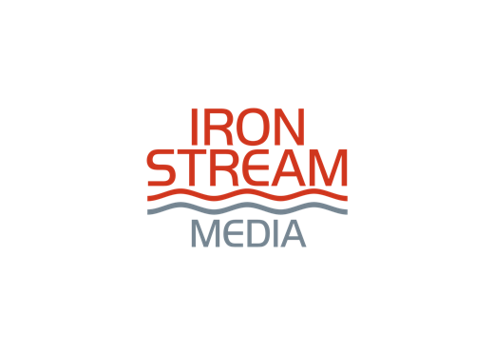

Book Proposal

Title Goes Here

Subtitle Goes Here

Author name here

Instructions for Authors
(Delete this box upon completing the proposal)
1. Delete the (explanation copy) after you’ve filled out the specific areas.
2. Single space the proposal, but double space the sample chapters.
3. Read over the proposal and sample materials thoroughly before submitting. Consider paying an industry professional to edit before submission. A proposal full of typos and verb issues will sink your chances at getting picked up.
4. Don’t scrimp on your marketing plan. Read several books on book marketing or set up a consultation with a marketing expert. Only include ideas you can implement and are affordable for you. The importance of the marketing section of your proposal cannot be overstated.
5. A good book proposal will take four to six weeks to write. Focus on overview, marketing, and comparables early in the process because each typically take the longest time to finalize.

Proposal Contents

- Brief Description
- Overview
- Audience
- Unique Selling Proposition
- Biblical Foundation
- Felt Need and Book Mission
- Format and Details of Manuscript
- About the Author
- Author Publishing History
- Author Marketing
  - Tribes
  - Affinity Groups
  - Potential Endorsers
- Author’s Future Books
- Comparable Titles
- Chapter Outline
- Sample Chapters

I. Brief Description

(This is what the salesperson will use to sell to a retailer. It’s more of a tagline or logline, one sentence of 25 words or less that creates interest in the book. Notice the words “creates interest” not “explains the book.”)

II. Overview

(In 75-100 words tell what your book is about. A lot of detail is not needed here, just enough that someone could have a quick conversation about your story / message. You’ll provide more detail in the Chapter Summary section.)

III. Audience

Primary:

Secondary:

Tertiary:

IV. Unique Selling Proposition

If consumers in the target market purchase and read (name of book), they will:

1.
2.
3.

Because the book will:

1.
2.
3.

V. Biblical Foundation

(If appropriate, include a couple of passages that form the basis of the book.)

VI. Felt Need and Book Mission

(What are the heart-felt reasons why someone would buy this book? What makes it compelling?)

When the reader has finished this book, here is what I’d like them to think, feel and do:

Think:

Feel:

Do:

VII. Format and Details of Manuscript

- Word Count:
- Current Status:
- CBA Bookstore Section: (Determine the section by choosing from the list here: https://bisg.org/page/BISACEdition.)
- Book Format: (Quality Trade Paper or Hardcover)
- Price Point:
- Book Pages:
- Deadline: (Usually a certain number of months from a signed agreement)
- Special Features: (Photos, appendices, side bar quotes, three-week devotional…anything that is “extra” to the body of the main text)

VIII. About the Author

(Brag on yourself in the third person. Read author bios on the back of other books or online (Amazon) in your genre. Also, answer the question: Why are you the right writer for this book?)
If desired, insert headshot here

IX. Author Publishing History

(List every book, year published, up-to-date sales.)

X. Author Marketing

(This is often the “make or break” section of a proposal. A publisher wants to know how you can sell your book. Show what you are doing now—social media, as well as public speaking (current and in the last 12 months), radio and TV. Also, what you plan: Will you create freebies to help with pre-orders? Can you arrange a bulk-purchase plan with a ministry or organization? Will you make arrangements to coordinate with your ministry’s retail store/website? This is not a wish-list or an explanation of what you’re willing to do. This will tell the publisher what contacts you already have and what you can, and will, do. This section should be three to five pages or more. Remember: Only include what you can implement and can afford.)

Tribes

- Facebook Friends: (Include the url of your account.)
- Twitter Followers: (Include the url of your account.)
- Website: (Include url and number of page views/month.)
- Blog: (Include url and number of unique visitors/month, number of page views/month, number of comments to blog posts during the last year.)
- Speaking engagements in previous twelve months: (Include venue and number of people in attendance.)
- Speaking engagements scheduled during the next twelve months: (Include venue and expected turnout.)
- Online columns or blogs you participate in: (Number of visitors.)
- Magazine articles published the last two years: (List publication date and circulation number of magazine.)
- Magazine articles schedule for release during the next twelve months: (List proposed publication date and circulation number of magazine.)

Affinity Groups

(A list of groups that might have interest in your topic / message. List as many as possible. Include readers of (name author), magazines, radio shows, and ministries. Consider interest groups that might be a large or small market.)

Potential Endorsers

(List anyone whom you already have contacted who can write an endorsement. This list should be people who have a vested interest in the topic.)

XI. Future Books

(List title and one-sentence description of each. Remember, publishers are looking for authors, not just books.)

XII. Comparable Titles

(Find three to five titles released in the last five years that are similar to yours. Two places to start are Amazon and Christianbook.com. Don’t skimp on this part. Publishers want to see that you know your market and the competition in it. For each title, you’ll need to know the following:
Name of publisher
Date of release
How your book is similar
How your book is different
It's best not to include blockbuster bestsellers or self-published books but do include well-known books with solid sales. Don’t criticize another book, just highlight the differences.)

Book Title by Book Author (Publisher, release year).
A one-sentence synopsis of the book followed by a couple of sentences about how yours is similar and the appeal to the same audience. Finish with how your book is different, unique, and distinct.

XIII. Chapter Outline

(Chapter titles with a one- to two-sentence explanation of the content in the chapter. Brief is best.)

Chapter 1. Description here.

Chapter 2. Description here.

Chapter 3. Description here.

XIV. Sample Chapters

(Always include the intro, if you have one, and at least two chapters. These chapters must be edited prior to submission. If you hire a book professional to edit your proposal, have them edit your sample chapters as well.)

